Default Settings – Loading:

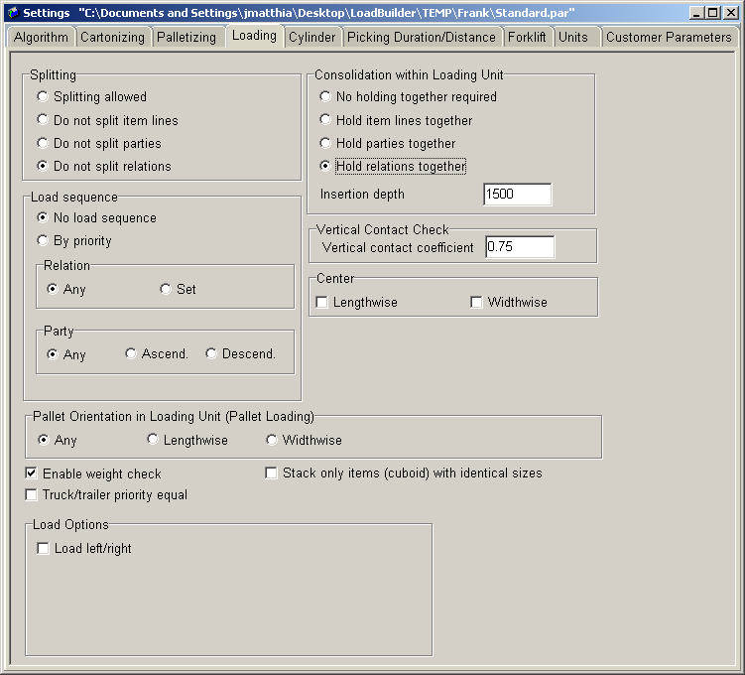

Used to set specific policies that will be used when calculating a loading pattern for the trailer.

Relevant Fields:
Splitting: Should always be set to “Do not split relations”. In the WMS a relation is referred to as a stop.

Consolidation within Loading Unit: Is usually set to “Hold parties together” or “Hold relations together” this is evaluated on a customer to customer basis and varies based on functional requirements. Most commonly set to “Hold parties together.”

Enable weight check: Always enable.

